GV249 Summative 1: Problem set
Candidate Number: 48372
Word counts:
PART I
Q1-(a): 198 (Max 200); Q1-(b): 196 (Max 200)
Q2-(a): 297 (Max 300); Q2-(b): 196 (Max 200); Q2-(c): 197 (Max 200)
Q3-(a): 253 (Max N/A); Q3-(b): 498 (Max 500)
PART II
Q(a): 128 (Max N/A)
Q(b): 550 (Max N/A)
Q(c): 252 (Max N/A)
Q(d): 175 (Max N/A)
Q(e): 196 (Max 200)
PART III
Exercise 1
1(a): 429 (including code, Max N/A); 1(b): 271 (including code, Max N/A)
Exercise 2
2(a): 325 (including code, Max N/A); 2(b): 269 (including code, Max N/A);
Exercise 3
3(a): 189 (including code, Max N/A); 3(b): 132 (Max N/A); 3(c): 71 (Max N/A); 3(d): 269 (Max N/A)

Total Word Count (PART I: Q1 Q2, Q3b, PART II: e): 1778 (MAX 1800)
Total Word Count (ALL questions): 5091 (MAX N/A)
Part I
Q1-(a):
Sartori’s “ladder of abstraction” is a hierarchical framework. It organizes various concepts from the same topic based on their degrees of abstraction, and then ranks them from abstract to precise. Take the concept “war” as an example, this hierarchical rank might be:
1, Conflicts
2, Violence
3, Any military action
4, War
5, Second World War (WWII)
6, Normandy Landings
These 6 ranks are a representation of ladder of abstraction for war that ranks its related concepts from the most abstract one: conflicts, to the least abstract one Normandy Landings. Note one could have any number of ranks, so it does have to be 6 like my example.
The ladder of abstraction enhances the reliability of comparisons by systematically categorized concepts, which is especially useful in maintaining consistency between researchers. For example, if two researchers are working on the topic war: A defines “war” as military actions, which include some minor internal/local conflicts, while B defines it as officially declared state wars between countries. This will lead to inconsistency in data collection and communication. However, the ladder of abstraction could efficiently tackle this problem, because A’s definition of war is actually “any military action” under this ranking system.
Q1-(b)
Validity means whether researchers actually measure what they “want” with appropriate methods. And reliability means whether an observation is consistent, and could be replicated with different conditions (time, space…). Thus, to operationalize the definition of “war” from 1(a), my 2 measures are:
1, wars are officially declared armed conflicts between states that cause more than 10,000 battle-related deaths.
2, wars are officially declared armed conflicts between states that last more than 1 whole year.
Validity:
When we research wars, we are looking for their potential influences on culture, economy, morality, and numerous other fields of human society. Thus, I personally think the death-count measurement is better than the duration measurement. There are some wars that are long-lasting, but it does not mean that they have large impacts on human society. For instance, Hundred Years' War is much longer than WWII, while the latter brings much more impact on human society.
Reliability:
They are both relatively reliable as quantitative measurements, but duration measurement may face challenges in measuring modern, or future wars because of the introduction of nuclear weapons, which challenges its reproducibility.
In conclusion, death-count measurement is preferable to duration measurement considering the validity and reliability.

Q2-(a):
Hare and Jones conceptualize Identity Activism (IA) as the “the inclusion of the Ukraine flag emoji in their Twitter/X accounts’ name section or Bio section”, in which they regard this as a measurement for the support of Ukraine in the 2022 Russian invasion.
To operationalize, they introduced a method called Longitudinal Profile Sampling (LOPS).
Step 1, for everyday between Jan.1 and Jun.30, they collect a random daily sample of tweets that are posted by U.S. users using Twitter Streaming API.
Step 2, they scan if users’ names/Bios contains the Ukraine flag icon (U+1F1FA U+1F1E6).
Step 3, they divide the number of users who have Ukraine flag icon to the total number sampled, then times 10,000 to represent “For every 10,000 U.S. Twitter/X users, how many users display the flag”.
Step 4, they track the change in this number over time.
Step 5, they also investigate follower/following lists of “flag users” to find out social connections between “flag users”.
To evaluate this measure, I would start with validity and reliability. For validity, this study wants to observe the phenomenon of IA in supporting Ukraine on Twitter/X; Finding the Ukraine flag icon is a very good measurement to quantify this IA because it is an “unambiguous indicator”: users with this icon are very likely supporters of Ukraine. However, the problem is that Twitter/X users will also represent IA in other ways like profile images or slogans instead of flag icons, which are ways that this measurement does not include. For reliability, this measurement uses data from an official API provided by Twitter/X itself, which is highly reliable, and also very convenient to be replicated since this API is unlikely to stop running, which means researchers from many years later could still access the same data to verify its correctness.

Q2-(b):
Sample data collected by Hare and Jones ranged from 2022-01-01 to 2022-06-30. In general, Ukraine-related IA in this time range first experienced a dramatic increase, then stabilized in bios while declining in names.
More specifically, in the beginning (January and early February), the Ukrainian flag was very uncommon, and almost nobody would include it in name or Bio. Researchers also find that it is ranked last in prevalence in bios, though the last is shared with 483 other emojis.
However, the prevalence of the emoji grew extremely significantly in late February (17-27 February), when users who display Ukraine flag icon in their name or Bios increased from both almost zero to 95 and 32 per 10,000 users respectively. This growth was also witnessed in the prevalence rankings, in which they separately climbed to the 2nd and 11th places in March.
After that, the ‘prevalence in name’ figure then peaked on 6 March at 108, However, this number drops continuously in the consecutive 3 months, which brings its figure to around 60 at the end of June.
The ‘prevalence in Bios’ statistic, however, remained stable at around 30 from March to June, with only some minor fluctuations.

Q2-(c):
Strengths:
This study designs a very efficient measurement of IA. Initially, investigating whether users demonstrate IA about supporting for Ukraine is a complicated and time-consuming task, due to the fact that there are various representations of IA on Twitter, such as hashtag topics, tweets, retweets, profile pictures… For researchers aiming to analyze a large volume of samples (in our case, it is roughly 100,000 tweets everyday), it is challenging to cover all these activities of different forms. However, they simplify the process into a binary criterion/standard. In contrast to subjectively analyzing transcripts in tweets or identifying the meaning of profile pictures, the presence or absence of a Ukrainian flag in a name or Bio is objective and binary: only true or false.
Weakness:
However, the study focuses solely on emoji-based IA, leaving us unaware of what happened to other forms of IA, and how they changed after Russia’s invasion. In my opinion, researchers are recommended to at least estimate a rough proportion of IA demonstrated by any non-Emoji forms. If this proportion is large, focusing exclusively on emojis will be inappropriate, as it indicates this measurement is invalid because it did not fully capture IA’s full scope.

Q3-(a):
The generation of the switching equation is due to the fundamental problem of the “Treatment and Control Methodology”, which is one person could only experience one condition in the real world. This is problematic because if scientists want to find out any causal effects, they will use this formula:

$$Causal Effect = Y(1) - Y(0)$$
Where Y(1) is the outcome of treatment, Y(0) is the outcome of control/non-treatment

But because scientists could not attain both data for Y(1) and Y(0) from the same individual. In other words, that means the individual counterfactuals are unavailable. They will have to collect data from a sample of individuals, and use the sample average value of Y(1) minus the average value of Y(0) to estimate the causal effect:

$$Estimated Causal Effect / Average Treatment Effect (ATE) = \overline{Y_{1}} - \overline{Y_{0}}$$

However, in order to find the average values for both treatment and control groups, scientists need to figure out whether one observed outcome is under treatment or under control. And that is the purpose of the switching equation:

$$Y=W⋅Y\left(1\right)+\left(1-W\right)⋅Y\left(0\right)$$
Where W is the indicator, W=1 means treated, W=0 means controlled; Y is the final observed outcome.
Y(1) becomes potential outcome under treatment; Y(0) becomes potential outcome under control

Also, researchers would generally record these observed outcomes in a table, including the indicator W. And when calculating group averages, they simply filter the data by W values to separate the treatment and control groups. This approach allows scientists to estimate the causal effect even when individual-level counterfactuals are unobservable in reality.

Q3-(b):
In Ansell and Samuels’ article, “result-free” is an approach that reviews studies based on theoretical framework and methodology design instead of results. I have summarized their criticisms about this approach into 2 sections:

Section 1: Evaluation Problem
A flawless methodology cannot guarantee meaningful outcomes, but the impact of studies relies on their theoretical contribution and practical relevance. This is therefore very challenging for reviewers, as they can assess neither without results. All they can do is focus more on the methodology part to find some clues that might suggest whether a study is “valuable”. Broadly speaking, this reduces the efficiency of the reviewing process and the quality of publications. We cannot deny the possibility that, due to the limited space of journals, meaningful works are crowded out by result-free works.

Section 2: Bias Problem
One major purpose of result-free publication is to reduce bias like p-hacking and HARKing, through requiring pre-registration for studies. To avoid cheating, researchers must submit and stick to their hypothesis and analysis methods before/when collecting data. Ansell and Samuels acknowledge its effectiveness in reducing traditional biases. However, they think this approach will raise many new biases. In their opinion, studies that possess these 2 features are more favoured:
1, use “classic”, verified, and familiar methodologies.
2, related to popular topics or current affairs (e.g. Covid studies in 2022).
These “reviewer biases” are harmful to academic study. For the 1st feature, it pushes people to do “safer” research, not only because they are worried that innovative methods will not be approved, but also because they cannot adjust methodologies halfway, so they must minimize risks. For the 2nd one, it restricts innovation and academic landscape. Popular topics often reflect the interests of influential funding agencies. To secure funding and publication opportunities from them, researchers are pushed to align with popular topics.

However, Arcenaux has provided a new angle for the result-free approach. He also talks about how it can reduce traditional biases. But unlike Ansell and Samuels, he argues that it actually encourages brave and unpopular researches.

Naturally, due to fear of wasting time and funds on unexpected or null results, researchers prefer traditional topics and methodologies, but a result-free approach provides them with the capital to take risks. A study that challenges well-established theory, but gets null results would be published anyway because its methods and questions were pre-approved. The result-free approach regulates a systematic evaluation process, which requires reviewers to focus on whether a study is well-designed and scientifically sound, and if yes, the study should be approved no matter what happens to the results.

Personally, I think Arcenaux’s perspective on bias problems is more reasonable. I do not think the problems about biases that Ansell and Samuels mentioned are brought by non-results approach. Instead, I think they are natural human biases, but their impacts could be effectively reduced under Arcenaux's inference. However, I do agree with Ansell and Samuels on their reasoning about result-free approach makes evaluation more complicated and challenging for reviewers.

Part II
Q(a):
My Causal Research Question: How does the introduction of mandatory voting laws affect voter turnout rates in democratic national elections?

In this question, “national elections” means any type of election held to elect a government/authority entity at the national level in democratic countries. Using this term is because there are some democratic countries running presidential systems, while others run parliamentary systems.

The explanatory/treatment variable X in this question is “the introduction of mandatory voting laws”. Note the term “introduction” means I will choose democratic countries where mandatory voting was initially not required, but later introduced as data sources.

The outcome variable Y in the question is simply the voter turnout rates: a percentage figure suggesting the proportion of how many eligible voters actually vote in a national election.

Q(b):
Variable X:
My proposal question is not simply comparing the voter turnout rates from countries with mandatory voting to countries without. Instead, my question focuses on “changes”. How does the change in law make one country’s voting turnout change. Therefore, my first operationalization for my treatment variable X will be to differentiate whether a national election is held under compulsory voting law or not.

The easiest way I can come up with is to set my X into a binary variable, where X = 0 means this national election IS NOT under compulsory voting law, and X = 1 means this national election IS under compulsory voting law.

Therefore, an appropriate measurement for X is to find documents that record the time when a country publishes its compulsory voting law. To ensure reliability, I will find multiple records of that time from reliable data sources and compare them to see if they are consistent. Some useful measurements for X will be:
1, Government official websites about voting behavior
2, the IDEA Compulsory Voting webpage
3, journals
4, books
Also, to determine if a data source is reliable, if it's a journal, I would look at its impact factor, and if it's a book, I would look at the H-index of its authors. I don't have a good way of verifying the reliability of government or IDEA pages, but I do think their data is more reliable because they are official organizations. Therefore, if there is any conflict between them and journals/books, I will use the time information obtained from the former. And after finalizing the specific time, I can set all X values after that time to 1 and all X values before that time to 0.

Variable Y:
Measuring Y is relatively easier than measuring X, not because it is technically easier, but because there are richer data sources for it, given that voter turnout rates are always popular topics in political study.

But before moving on to measurements, I want to first explain the operationalization of it. I want to calculate the statistic of voter turnout rate with this formula:

$$\text{Voter Turnout}\text{ Rate}\text{ (\%)}=\frac{\text{Number of Votes Cast}\text{ in one national election}}{\text{Number of Eligible Voters}\text{ in the same national election}}×100$$

To make this percentage meaningful, I also want to record the information about the country where the national election takes place, and the EXACT time when the national election happens. Because we will look for many elections from many countries, this will facilitate the linear regression analysis.

Given the formula, the measurements of voter turnout are actually measurements of voters cast and eligible voters. Here are some good instruments:
1, Government official websites about voters cast or even direct voter turnout data in any special election.
2, Data from government demographics departments about eligible voters.
3, IDEA’s Voter Turnout Database.
4, Journals and Books.
Similar to the measurement of X, Government websites and IDEA are still useful tools. But I think for the measurement of Y, journals and books are less useful because they generally do not have such a large landscape in covering all election data for one country. More likely they only contain a fraction of them, making finding information from them time-consuming. But luckily, most government websites and IDEA have a full documentation of these statistics.

Q(c):
Hypothesis:
The introduction of mandatory voting laws significantly increases voter turnout rates in national elections.

This hypothesis is clear, because it specifies the relationship between X and Y is CAUSAL by using the word “increase”. It outlines the direction of the change is positive, in which the increase in X will cause a corresponding increase in Y. It also described the extent of change as “significant”, which means the introduction of law poses a major impact on the voter turnout.

This hypothesis is testable.
1, The causality relationship could be tested, because there is a time sequence between X and Y. AFTER the mandatory voting law is published (X changes from 0 to 1), the voter turnout rate Y observes a change. We could observe results from many countries, which increases reliability.
2, The extent is testable. I have claimed that the change is significant, and this could be tested by linear regression analysis (By looking at the β1 and p-value)
3, The variables are testable. For X, it is a binary value of 0 or 1, and it is well-defined and well-coded. It simply means whether the national election is held under law enforcement or not. For Y, the meaning of voter turnout rate is well-defined with a formula: it is a percentage that represent how many eligible voters actually vote. Besides, for both X and Y, I have outlined a detailed list of data sources, so anyone who wants to verify can access these data sources to verify my work.

Q(d):
My linear regression model is:

$$Y_{c,t}=β_{0}+β_{1}X_{c,t}+ϵ_{c,t}$$

Yc,t is my dependent variable, which means the voter turnout rate in country “c” during national election period/time “t”. For instance, Y Aus,2019 means the national election take place in 2019 Australia.
Xc,t is my independent variable, which means the existence of a mandatory voting law in country “c” during the national election period/time “t”. For instance, X Aus,2019
β0 is the y-intercept, which is also the baseline. In my case, it means the voter turnout rate when there is NO mandatory voting law.
β1 is the slope of the regression line, which represents the effect of mandatory voting laws on voter turnout rates. It should be a value between -1 and +1. Being positive means a positive relationship between Yc,t and Xc,t, while negative means a negative relationship; The size of the number represents the significance of the relationship.
ϵ is the error term. In my case, it is the variation in voter turnout rate that cannot be explained by the presence of mandatory voting law.
Q(e):
The biggest methodological difficulty lies in the binary classification of variable X. I have categorized it using a simple standard: whether mandatory voting laws are present or not. However, in reality, mandatory voting laws vary significantly across countries. Due to the complexity of legal systems, there are fundamental differences in both the design and enforcement of these laws. This variation—ranging from strict penalties in some countries/states to symbolic or weak enforcement in others—is not fully captured by the simplistic binary approach used in this study.

Besides, I account little about the classic issue of confounding variables in my research. Factors related to culture, economics, and other domains can influence both X and Y, distorting the true relationships and leading to either overestimation or underestimation of the effects. While some research designs can rely on the randomness of the sample to address this issue—"assuming that the effects of confounding variables cancel each other out”—this approach is not feasible in my study. This is because my sample size is small. There are only a small portion of countries that introduced mandatory voting laws, and there are limited numbers of national elections within these countries.

Part III
Exercise 1(a):
In question 1(a), I am required to modify data structures and recode values for columns polinterest and edlevel.

For polinterest, I am first required to remove the “Don’t knows”, so I wrote the following code:
mydata <- mydata[mydata$polinterest != "Don't know", ]
mydata$polinterest <- droplevels(mydata$polinterest)
The first line uses “!=” to filter the column polinterest by not including values of Don’t know. This is because “!=” means not equal to in R (and in most programming languages).
The second line drops the unused level of Don’t know, which is not necessary. I am doing this just to avoid any potential trouble for next steps.

After that, I am required to recode the descriptive values like “very interesting” into numeric values, ranging from 0 (Not at all interested ) - 3 (very interested). Core code related to this is:
mydata$Polinterest_Numeric_Ver <- match(
mydata$polinterest,
c("Not at all interested","Not very interested","Fairly interested","Very interested")) – 1
There are some lines that are organized in a different format for readability in R, but I arrange them into one line here. The core function here is the match(), which automatically assigns numerical position values to values with defined order from left to right, which perfectly fits my requirements. However, the only issue is that it starts from 1, but I am required to start from 0, so I apply a -1 at the end of the code. Finally, I store the numeric version into a newly created column called “Polinterest_Numeric_Ver”.

For column edlevel, I am asked to recode it in a binary way. People who went to universities as 1, and who did not as 0. Core code:
mydata$binary_edlevel <- ifelse(mydata$edlevel %in% c("Undergraduate", "Postgrad"), 1, 0)
The function ifelse() is a classic binary recoding tool. In my design, it recodes only Undergraduate and Postgraduate as 1, and any other values like GCSE, below GCSE, and no qualifications into 0.

For demonstration, I am required to produce mean values, and any other meaningful values that can represent variation. Thus, I include as many values as possible, which include Variance, Standard Deviation, Standard Error, and Confidence Interval. Core Code:
summary_table <- mydata %>%
group_by(binary_edlevel) %>%
summarise(
mean_polinterest = mean(Polinterest_Numeric_Ver, na.rm = TRUE),
var_polinterest = var(Polinterest_Numeric_Ver, na.rm = TRUE),
sd_polinterest = sd(Polinterest_Numeric_Ver, na.rm = TRUE),
se_polinterest = sd_polinterest / sqrt(sum(!is.na(Polinterest_Numeric_Ver))),
CI_lower_polinterest = mean_polinterest - qt(0.975, df = sum(!is.na(Polinterest_Numeric_Ver)) - 1) * se_polinterest,
CI_upper_polinterest = mean_polinterest + qt(0.975, df = sum(!is.na(Polinterest_Numeric_Ver)) - 1) * se_polinterest
)

print(summary_table)
To finish this section, I will provide 2 images about the summary table, and the headings of the final data structure after modification:
Figure 1: Summary Table
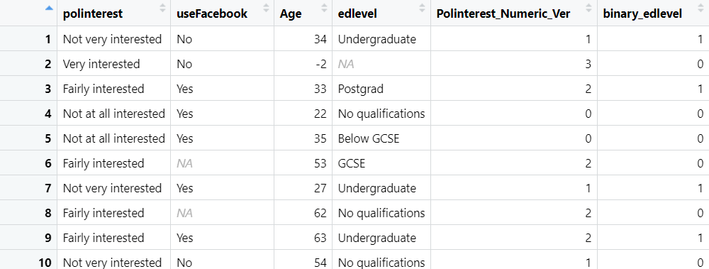
Figure 2: Headings of the data structure after modification

Exercise 1(b):
In this section, we are testing whether possessing a university education background is associated with political interest in the population of British voters.

My hypothesis H1 is there is a positive correlation between university education background and political interest. Correspondingly, the null hypothesis H0 will be there is no correlation between university education background and political interest.

To test whether my hypothesis is correct, I will need to conduct a linear regression analysis. I have designed the following formula for it:
$$\text{Political Interest (}\text{Polinterest}\text{_}\text{Numeric}\text{_}\text{Ver}\text{)}=β_{0}+β_{1}×\text{binary}\text{_}\text{edlevel}+ϵ$$
Unlike my regression model in Part II, this is just a standard linear regression model, so I will not explain too much about it. In general, β0​ is the intercept, β1 is the slope, and ϵ is the error term suggesting how many variations in Y (political interest) cannot be explained by X (university entry or not).
Doing regression analysis using R is simple, because I do not need to actually write the formula. Instead, I just need to specify which columns to include. Core code:
poli_edlevel_model <- lm(Polinterest_Numeric_Ver ~ binary_edlevel, data = mydata)
summary(poli_edlevel_model)
And the result is:
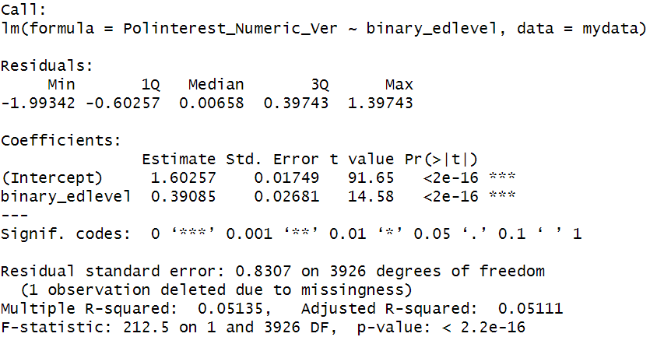
Figure 3: linear regression model for polintrest and edlevel
In the result, β0​=1.60257, β1​=0.39085, P-value = < 2.2e-16, R-squared = 0.05135
Because the P-value is extremely small, and we have 3 asterisks, we can reject the Null hypothesis H0 at the 99.9% confidence level. And there is strong evidence to suggest a significant positive relationship between university education and political interest in the population of British voters. However, the R-squared value is small, so there are many variations of political interests are not explained by university entry situation.

Exercise 2(a):
In this section, I am asked to produce a scatter plot which shows how Facebook use varies by age. However, according to the description, I need to modify the age column beforehand.

I need to set all ages above 90 as 90, Core code:
mydata$Age <- ifelse(mydata$Age > 90, 90, mydata$Age)
This code uses ifelse function as well, which I have explained how it works at the previous section.
Then I need to remove all missing variables. Core code:
mydata$Age <- ifelse(mydata$Age < 0, NA, mydata$Age)
mydata <- mydata[!is.na(mydata$useFacebook), ]
mydata <- mydata[mydata$useFacebook != "Don't know", ]
In my earliest design, I only had the second line of code, which utilizes “!is.na” to remove NA values. But after I plotted the diagram, I found that the scale of age goes to -1000, then I realized that the “missing values” does not mean that they are NA values, but means that there are very abnormal values that cannot be true in reality. For instance, -998 years old. Thus, I added the first line of code to set all negative ages into NA variable, and then remove them with the second line of code.

I have also found that there are “Don’t Knows” in the dataframe. I think this is unneeded and confusing, so I removed it.

After that, I can plot the scatter graph:
library(ggplot2)
ggplot(mydata, aes(x = Age, y = as.factor(useFacebook))) +
geom_jitter(width = 0.5, height = 0.2, alpha = 0.5) +
labs(x = "Age", y = "Facebook Use", title = "Facebook Use by Age") +
theme(plot.title = element_text(hjust = 0.5))
I use ggplot to generate scatter plots. The code block is long, but the actual important part is just setting values for width, height, and alpha. Generally, there is a common range for these values, but I still manually adjusted them for better visual representation. And the final graph looks like:
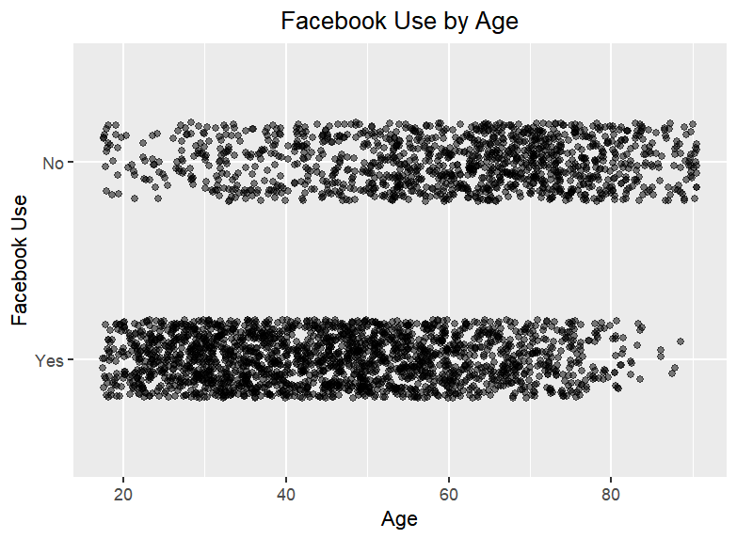
Figure 4: Scatter Plot of how Facebook usage varies by age

Exercise 2(b):

In this question, I am required to plot the graph again, but this time with a linear regression line this time. Core code:

ggplot(mydata, aes(x = Age, y = as.numeric(useFacebook == "Yes"))) +
geom_jitter(width = 0.2, height = 0.05, alpha = 0.5) +
geom_smooth(method = "lm", se = TRUE) +
labs(x = "Age", y = "Facebook Use (1 = Yes, 0 = No)", title = "Facebook Use by Age (with Regression Line Ver)") +
theme_minimal() +
theme(plot.title = element_text(hjust = 0.5))

The overall structure is similar, and I still use ggplot and inherit many parts from 2(a). However, the major change is I added a new function geom_smooth which can generate a line. I set the method as lm (linear regression model), and also included standard error even it is not specifically required in the question. I am doing this because I find it helpful to understand more about the relationship. In the diagram, the grey shadow area is the Confidence Interval region, which you can see that it is narrow in the middle and wide at both ends. This is very likely because there are more scatter plots and more sample data lies at the center, and fewer lies at both ends.

Apart from that, I also modified the values for width, height, and alpha for visual demonstration because values I used in the previous question look very weird here. Finally, the graph looks like:
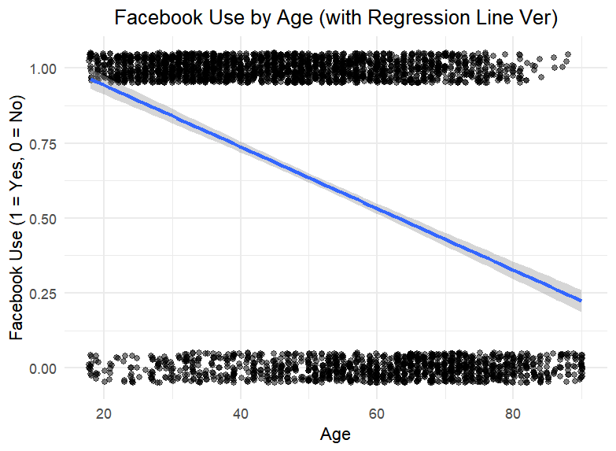
Figure 5: Scatter Plot with linear regression line
We could observe from the graph that the gradient of the line is NEGATIVE, which suggests that the relationship between age and Facebook is negative.

Exercise 3(a):
The OLS regression model is:
$$\text{Facebook Usage}=β_{0}+β_{1}⋅\text{Age}+ϵ$$
Facebook Use: The dependent variable, coded as 1 for "Yes" (use Facebook) and 0 for "No".
Age: The independent variable, measured in years.
β0​: The intercept, representing the predicted Facebook use for someone aged 0 (hypothetical baseline).
Β1: The slope, represents the change in the likelihood of Facebook use for each additional one year of age change.
ϵ: The error term, capturing the variability in Facebook use not explained by age.

Code version of the linear regression model:

mydata <- mydata[mydata$useFacebook %in% c("Yes", "No"), ]
mydata$UseFacebook_Binary_Version <- ifelse(mydata$useFacebook == "Yes", 1, 0)

model <- lm(UseFacebook_Binary_Version ~ Age, data = mydata)
summary(model)
The first two lines transfer the data structure from yes and no to 1 and 0. I have done similar procedures to education level before, and this time it is simpler because raw data only has 2 categories, while the education level has many categories.
The rest part is the regular procedure of linear model analysis. The result is:
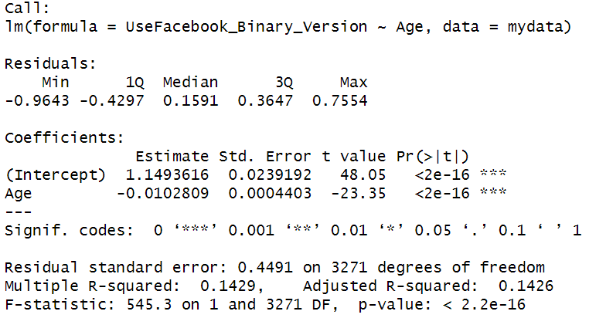
Figure 6: Linear model for individual Facebook usage on Age

In the results, β0​=1.1493616, β1​=-0.0102809, P-value = < 2.2e-16, R-squared = 0.1429.

Exercise 3(b):
From the extremely small P-value and β1​=-0.0102809, we have enough evidence to say that it is extremely likely that there is a MODERATE NEGATIVE correlation between age and Facebook usage in the population of British citizens. Statistically speaking, the P-value is smaller than 0.001, which means we are 99.9% confident that this correlation exists. This means when age increases by 1 year, Facebook usage decreases by nearly 1 percent, which is a moderate relationship.

However, the R-squared value is not very large (0.1429), and this suggests that there are many other factors that also influence Facebook Usage, and most of the variability in usage is actually explained by them. Taking this into consideration, I would finally conclude the relationship between age and Facebook usage in the population of British citizens as Weak-to-Moderate.

Exercise 3(c):
To answer this question, we will need the regression analysis results from 3(a):
β0​=1.1493616, β1​=-0.0102809, P-value = < 2.2e-16, R-squared = 0.1429.
For this question, we only need values of β0 and β1.
Because we have the formula as predicted Facebook Usage = β0​ + β1​⋅Age, we plug in the value for Age: 27, and we will get the value of the predicted Facebook Usage is 0.872 (3 significant figures).

Exercise 3(d):
Likewise, we plug in number for Age: 16. Using the same formula: predicted Facebook Usage = β0​ + β1​⋅Age. We can find out that the predicted Facebook Usage is 0.985.

When estimating Facebook use among 16-year-olds people based on the BES 2019 sample, we do need to keep in mind that:
1, this database is initially designed to study the correlation between political interests and education levels, we must remember that our research topic: Facebook and Age is not the primary one, and not what this data is designed to provide information about.
2, the age 16 is problematic because this is too young. In my opinion, young respondents will be underrepresented in this sample because this dataset is studying political behavior, and at that age, it is hard to say they are truly, and legally engaged in political activities. Besides, it is also an ethical problem to do surveys to non-adults, which is another explanation for why I think the data size will be small for this age group.
3, the most important one is you will find out the intercept is 1.1493616. Practically, this number is impossible to go beyond 1, because 1 already means 100% likelihood. But if the age is small enough (e.g. Age =10), you will find out that this value is larger than 1, meaning that the likelihood is > 100%, but a likelihood > 100% is not meaningful at all. Thus, we could say that this linear model does not function properly with extreme values in age. I think one reason for that is because of the small sample in extreme ages.

